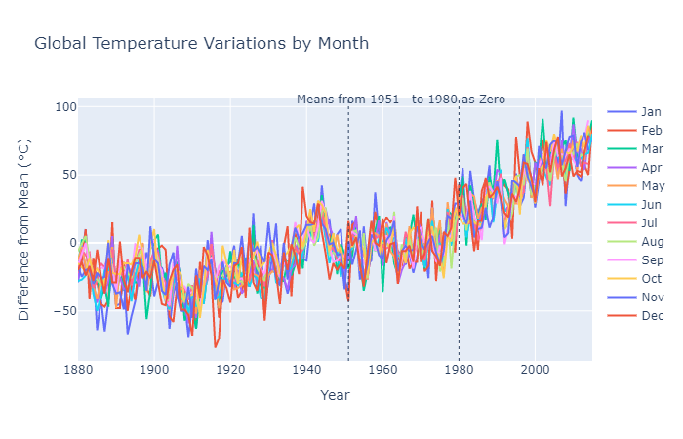

* X-axis is Year and Y-axis is Difference from Mean.
* This plot shows the Global Temperature Variations by Month from Jan to Dec.
* Higher deviation of annual mean temperatures over the years, especially between 1980 and 2000.
* The annual temperatures have risen most significantly since 1990.